Topic: The Internet and Web Browsers
When I am done this lesson, I will know:
- What the Internet is
- What an Internet browser is
- How to use some of the functions in a common Internet browser

Pre and Post Self-Assessment
 | Pre | Pre | Post | Post
 | Yes, I know this | No, I want to learn this | Yes, I know this | I still need more practice to learn this
I know what the Internet is
I know what an Internet browser is
I know how to use an Internet browser

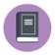
New Words and Terms
World Wide Web (www)
email
URL
browser
address bar
refresh
tab
cache
What is the Internet?
The Internet is an electronic infrastructure that connects different networks so they can share information. It is the largest computer in the world, which connects billions of computers.
A network is a group of two or more computers systems linked together.
The World Wide Web (WWW) is one of the networks on the Internet. There are other networks for things such as email, online games and file sharing.
Why Do We Need to Use the Internet?
In the world today, many things we do every day are done online or can be done online. You need to have good computer skills and use the Internet to do things such as:
- Research
- Shop online
- Search for and apply to jobs
Keep in touch with friends and family

Discussion QuestionS
Can you think of any other things we use the Internet for every day?
The World Wide Web (WWW)
The World Wide Web is a network of connected websites. Websites are stored on servers all over the world. To get to a specific website you can type in the address of the website which is called the URL. URL is the short form for the term Universal Resource Locator or Uniform Resource Locator.
URLs
To get to a webpage you can type the uniform resource locator or URL into the address bar in a browser or a search engine.
The URL is also known as the website address. It tells the browser or search engine exactly where to find the website.
For example: www.google.ca
Web Browsers
You need to use a web browser to connect to the World Wide Web. A web browser is software that lets you access information on the World Wide Web. Some common web browsers are:
- Internet Explorer
- Google Chrome
- Safari
- Microsoft Edge
- Mozilla Firefox
Netscape Navigator
Most web browsers have common features and function in very similar ways.
Google Chrome
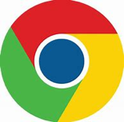
This lesson will show you how to use Google Chrome. Google Chrome is a free web browser. The symbol for Google Chrome looks like this:
To open a Google Chrome Browser, you can click on the icon in your task bar at the bottom of your screen.
If you are using a computer with a Windows operating system, you will also see an Internet Explorer icon on your taskbar. It looks something like this:
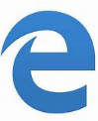
Once you click on the Google Chrome icon the web browser will pop up on your screen.
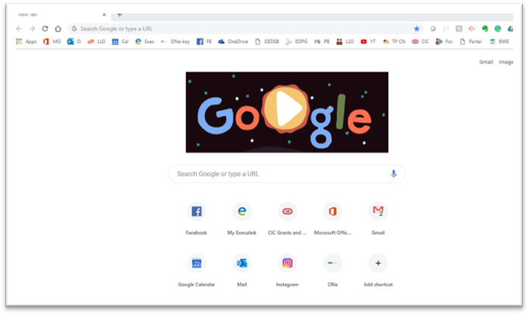
This called a HOME PAGE.
The home page is the first webpage that is opened when you start a web browser. You can always return to the home page by clicking on the home icon. The home icon is found to the left of the address bar. It looks something like this: 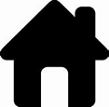
Address Bar
When you know the exact URL or webpage address, you can type it into the address bar.
Backwards and Forwards Buttons
The browser has buttons that let you go backwards and forwards.
- If you click the back button, it will take you to the previous webpage.
- If you click the forward button, it will go forward to the previously viewed webpage.
Stop Button
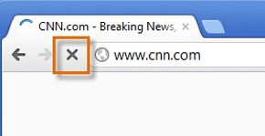
The stop button is an X and it will appear when a webpage is loading. You can click on the stop button to stop downloading a webpage if you change your mind.
Refresh Button
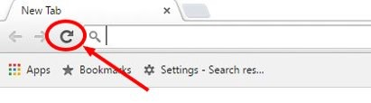
You can use the refresh button to re-load your current webpage if you are having a problem. You can also use it to update the page if the information is updated frequently.
Scroll Bar
The scroll bar allows you to move up and down a webpage quickly. The scroll bar is found on the right-hand side of the web browser. To use the bar, put your cursor on the bar and left click. You have to click and hold down and then you can move the bar up and down. You can also click on the arrows at the top or bottom of the scroll bar to move up and down a webpage.
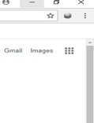
Tabs
You can have multiple webpages open at the same time. Each page will have a tab at the top of the browser. You can move from page to page by clicking on the different tabs. When you click on a tab it will open that page. You can close a page by clicking on the X that is located on the tab. If you want to open a new tab, you can click on plus sign (+) at the far left.


Try this/Practice
- Open the Google Chrome browser by clicking on the icon on the task bar at the bottom of the screen.
- Type www.llsc.on.ca into the address bar.
- Practice scrolling up and down the page using the scroll bar.
- Open a new tab at the top of the page.
- Close all the tabs.
Myths and Truths about the Internet and Web Browsers
Myth | Truth
If I just look at a website on the Internet, I will be safe. | If a site has malware on it, simply browsing or looking at the site can allow a virus to download to your computer if it is not protected. If you are suspicious about a website, don’t open it!
Clearing your cache in your web browser will make your computer faster. | A web browser will store cache files which are offline copies of things you have downloaded. If you clear out your cache, it will actually slow down browsing the web because your browser has to re-download everything again.
You must type “www” before a web address. | This is another myth that grew out of fact. Originally, the Internet was designed so that “www” was a necessary part of a website’s address. However, today, all you have type is the website’s domain name. (Note: you still need to include the “dot com” part of the address for this to work.) For example, typing “bask.com” into your web browser will take you directly to the Bask homepage. Try it with sites like “google.com” or “pinterest.com.”

Optional: I Want to Learn More
To learn more about Google Chrome’s features, review this tutorial from GCFGlobal:
https://edu.gcfglobal.org/en/chrome/getting-started-with-google-chrome/1/

Ontario Adult Literacy Curriculum Framework Connection
Competency | Task Group(s)
Find and Use Information | Read Continuous Text (L1, L2 – a range in specialized vocabulary)  Interpret Documents (L2- compare and contrast documents/search engines)  Extract Information from Films, Broadcasts and Presentations (not levelled)
Communicate Ideas and Information | Complete and Create Documents
Using Digital Technology | Perform Simple Searches (L2)  Locate and Recognize Functions/Commands



